Broward Sierra Bulletin
VOL. XLIII NO. 9 September 2021

www.sierraclub.org/florida/broward • www.facebook.com/BrowardSierra
https://www.meetup.com/Broward-County-Sierra-Club-Group/ • https://twitter.com/BrowardSierra
(That’s right, we now have a Twitter account – check us out!)

Broward Sierra Club General Meeting
Time: September 2, 2021 at 07:00 PM EST
For our September general meeting, the Broward Sierra Group is pleased to host Tracy Raczek. Ms. Raczek will make a presentation on the topic of “Dominant global trends, economic, political and social/ behavioral, that may influence climate solutions in the next decade plus.”
For over 20 years, Tracy Raczek has worked on shaping science-based climate change and sustainability policy and partnerships.
She served for over 10 years in the United Nations including as an advisor to Secretary General Ban Ki-moon in lead up to the Paris Climate Agreement. This included delivering a breadth of multi-stakeholder climate commitments in close collaboration with leaders across government, industries, and civil society.
Ms. Raczek has also collaborated with experts and advocates from around the world to advance climate action and sustainability via other UN resolutions, the Sustainable Development Goals agenda, best practices sharing, and considerable publications – all the while integrating social dimensions including equity and gender equality.
Please register in advance for this meeting:
https://act.sierraclub.org/events/details?formcampaignid=7013q000001kuVNAAY&mapLinkHref=
After registering, you will receive a confirmation email containing information about joining the meeting.
https://www.meetup.com/Broward-County-Sierra-Club-Group/events/279513001/

Upcoming speakers:

October 7: Louis Aguirre. Note: Usually, our presenters begin about 7:20ish! At this meeting, our presenter will start promptly at 7:00 PM, as he must leave us by 8:00ish. Sierra business will follow his presentation. Please be in attendance before 7:00 PM. Louis Aguirre is our Local 10 WSFL newscaster for both early evening and late-night. He is the anchor and environmental advocate. Louis will be speaking to us about a profoundly serious and timely Florida issue… Keeping Our Community Pristine! Please mark your calendar and don’t be late! Thank you!

November 4: Chuck O'Neal – He will be discussing FL5.org and the 5 amendments for the 2022 ballot (please click the following link and review the petitions: https://fl5.org/).

Upcoming Event – First Aid Training
Sierra Club is having a 4-hour First Aid and CPR Course on September 25, 2021 at Anne Kolb Nature Center in Hollywood. The cost for attendees is $75.00 and there are still 5 spots open. For questions, please contact Adriene Barmann at adrienesierraleader@gmail.com

Fisheating Creek Outing
Adriene Barmann, Outings Chair, Broward Sierra Club
Yes, National Sierra Club has given the OK for camping trips once again, so Max Goldstein, our Outing Co-Chair, and I are busy planning our next camping adventure at Fisheating Creek scheduled to take place on October 22 – 24, 2021.
Fisheating Creek, just west of Lake Okeechobee in Highlands County, is a spectacularly scenic legendary creek and its landscape will open one's eyes to the true beauty of old Florida. The ancient Cypress trees and their distinctive knees encompass the creek and the campsites which are also surrounded by hanging Spanish moss, and beautiful air plants; each tree's shape is unique and full of personality. The water in the creek looks like reflective glass, and in some areas of the creek, the reflections on the water mirror its beauty. While in other areas, the water is so clear you can see the ridges in the sand at the bottom of the creek. In and around the creek, the sights and sounds of wildlife include birds squawking and trilling, herons and wood storks flying around the Cypress trees, near dozens of alligators lounging at the shores of the creek. The campground at Fisheating Creek Outpost, is part of the Florida Fish and Wildlife Conservation Commission’s Fisheating Creek Wildlife Management Area. We have secured six campsites located in a cul-de-sac near the creek, which is a short walk to the outpost where we plan to paddle on the creek. On Sunday we will take a guided hike at Fort Center which is a 13-mile drive from Fisheating Creek.
The weekend will include 3 meals sponsored by Broward Sierra Club, a 6-mile kayak trip on the creek, the Fort Center hike, and engaging discussions during meal times. There will also be plenty of time to sit back and enjoy the sights and sounds of nature.
Please sign up on this link. All the costs are explained and once you sign up you will receive more details about the trip.

Leaders:
- Adriene Barmann, Mobile: 954-328-9447. Email: adrienesierraleader@gmail.com
- Max Goldstein, Mobile: 954-296-3411. Email: maxgold@yahoo.com

Starting time: Friday, October 22nd, 2021 at 2 PM. Check-in time is 2:00 PM Friday, check-out time is 2:30 PM Sunday.
https://www.meetup.com/Broward-County-Sierra-Club-Group/events/280284373/?isFirstPublish=true

Dune Restoration
Leah Weisburd, Chair, Broward Sierra Club
We are so proud of our two, very dedicated, Broward Sierra members. Victoria Olson and Jared Stein were among others who took time out from their busy schedules volunteering to help restore the dunes in Hollywood by planting sea grass. In conjunction with Elaine Franklin, Hollywood’s Environmental Sustainability Coordinator, they helped restore the dunes on a hot Saturday morning. Thank you for all you do!
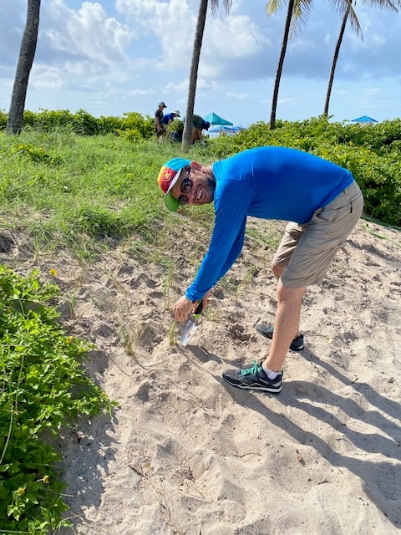 | 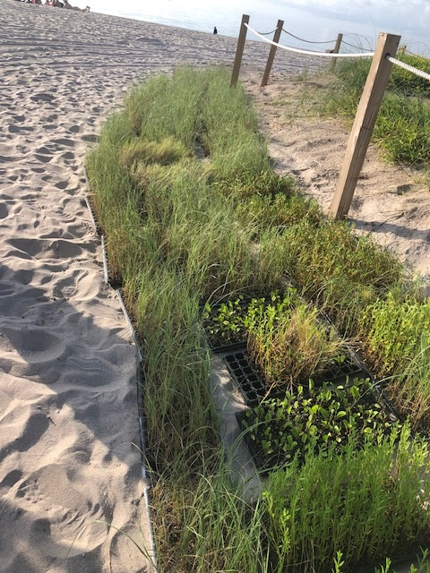
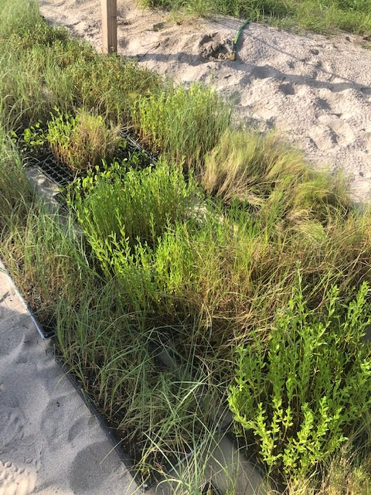 | 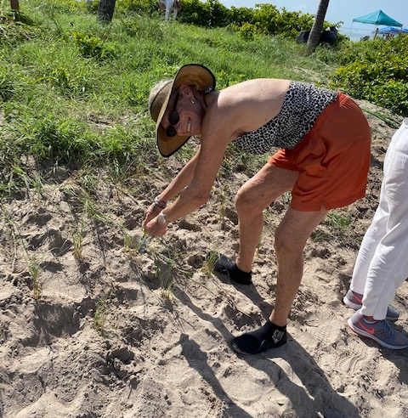

Links of the month:
In case you haven’t heard, the United Nations' Intergovernmental Panel on Climate Change says things are getting worse. This has been confirmed by NOAA. https://www.noaa.gov/news/its-official-july-2021-was-earths-hottest-month-on-record.
We must ALL make an effort to reverse what is happening!

Florida Friendly Landscaping
– Max Goldstein, Treasurer, Broward Sierra Club

Our August presenters were from the Florida-Friendly Landscaping Program (https://ffl.ifas.ufl.edu/). Floridians use 1.6 billion gallons of water every year (740 gallons / person / day). On top of that, 300,000 people are moving to Florida every year = even more water use.
So, we MUST make every effort to save all the water we can. And one of the best ways is Xeriscaping or Naturescaping: planting native, drought-tolerant plants. So, you can have a variety of colorful plants that can attract butterflies or you can keep the existing St. Augustine grass (which is very thirsty). I encourage everyone with a lawn to check out the above Website (and if your homeowners association objects):
https://www.jacksonville.com/community/shorelines/2010-01-30/story/new_florida_landscaping_law_supersedes_homeowner_association__0?fbclid=IwAR1FVkGEuYFkkIKDSDuoikisKRRdAxcn8hygr5wDzKKAH3XL-1163yWKTHk

Hello Stranger
– Leah Weisburd, Chair, Broward Sierra Club

We’d love to know you better! So, we are adding a new item to our Broward Sierra Bulletin called:
GETTING TO KNOW YOU.
Don’t be shy!
Many of our Sierra members lead, or have led, very interesting lives, so why not share your story with us.
Please send our editor, Max Goldstein, a short paragraph or two to print in our Bulletin along with a photo of yourself.
Our October issue will be published on September 30th. The deadline for submitting articles need to be sent to Max by September 23d at maxgoldstein@gmail.com. Please put in subject - Getting to know you.
We are all looking forward to knowing our members better!

Executive Committee Nominations
Leah Weisburd, Chair, Broward Sierra Club
We are accepting Broward Sierra member’s requests for nomination to serve on the Broward County Sierra Group-Executive Committee (ExCom). If you are elected by our members this December, your tenure will begin in January 2022 for a 2-year term.
Please don’t be left out…. Start the process now by sending the following information to excomleah@gmail.com. We encourage you to bring your ideas, your passion to protect our planet, and have fun doing so.
Please submit your bio (200-300 words or less), why you would like to serve on ExCom, what you would contribute if elected, and what organizations you have been, or are, a member of.
We usually meet the 1st Monday of each month. However, because of Labor Day, Jewish holidays, and member’s vacations, we are meeting on Monday, August 30th instead of our September meeting.
Please know that you are more than welcome to come to our ExCom meeting to see and hear us in action. You can find the Zoom link on our website.
Please don’t hesitate to contact me with any questions you may have. I look forward to hearing from you. Again, my email address is excomleah@gmail.com

Broward Sierra Political Corner – August 2021
– Susan Steinhauser, Political Chair

Click here for more info

Political co-chair – browardsierrapc@gmail.com
POSITION FILLED!! – MAE SMITH
Conservation Committee – susancaruso@gmail.com Sue Caruso Conservation Chair is seeking volunteers: The members of this committee shall work to preserve the natural resources and habitats of the native species of Broward County. That focus can lead to work beyond our county due to the interconnectedness of our vast watershed and human development. The duties will include bringing attention to proposed developments that are unsustainable and partnering with stakeholders to mitigate or stop such projects, working on local issues brought forth by our members, promoting community efforts that foster environmental justice and education, such as our community gardens, exotic plant removal and tabling events. Attending quarterly meetings will be required.
Media Chair – and 1 Committee volunteer – excomleah@gmail.com Write articles for publication. Send op eds to the Sun Sentinel and Miami Herald; publish articles in local city newsletters; write and publish in college newspapers; Perform speaking engagements for local organizations (via zoom for now) to gain members. Speaking on local radio shows. Committee - To assist Media Chairperson.
Membership Committee – dgbrowardsierra@gmail.com The members of this committee shall collaborate with the Chair, reaching out to schools, organizations, clubs, etc., to introduce them to the Sierra Club. Recruitment is a vital part of the membership team! Increasing our membership by presenting the many ways we protect, enjoy, and explore our environment. In addition, engaging our existing membership to participate & volunteer by inviting members to get togethers, i.e., wine & cheese get togethers, tea parties, garden parties, etc.

