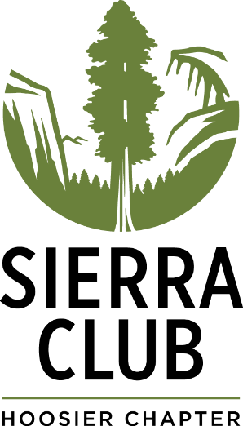
Sierra Club Hoosier Chapter
2019 Children’s Online Art Show –
Entry Form

Human/Nature
Children are invited to submit art reflecting on our natural world.
What is it about nature that is important to you as a child or young person? What animals and natural places do we need to protect? What do you want us to know?

Fill out this form and email with your picture it to rebecca.dien-johns@sierraclub.org or mail it to: Sierra Club Hoosier Chapter – 1100 W 42nd St., Suite 215, Indianapolis IN 46208.

About you:

Name____________________________________________________________________

Age__________

Phone number or email address (of parent/carer if under 18)_________________________

Title of artwork _____________________________________________________________

Where is your favorite place to be in nature?

Tell us something about you!

By entering this exhibition, I pledge that this artwork is an original composition. I understand it will be exhibited on the Sierra Club Hoosier Chapter website. I understand that images of my work may be used for promoting Sierra Club Hoosier Chapter.

Participant’s Signature/Parent or carer’s signature if under 18 (can be printed if emailing)
______________________________________

Parent/carer name_______________________

Relationship to child______________________

Date _____________

All children submitting art will be invited to an arts and craft workshop with a nature theme in Indianapolis this fall. More details will be provided.

