This Photo by Unknown Author is licensed under CC BY-NC-ND

Water Affordability
What are the issues and how did we get here?

Water affordability is a critical issue that local and federal governments are working on. Aging infrastructure, rising costs, increasing economic segmentation and toxins in the drinking water have adversely affected both water utilities and the low-income customer. Water affordability policies, regulations and infrastructure funding will ensure that all people have an equitable share of access to safe drinking water while protecting the environment.
We will work to assure that relevant voices of people directly affected are heard. We will work with other groups who share compatible visions to consciously act in solidarity and mutuality to support each other’s work. Water affordability is achievable through rates for low-income citizens, regulation of safe drinking water and water quality standards and infrastructure funding. Infrastructure funding for sewage treatment, drinking water treatment and distribution and grants for affected communities.

Introduction
The ability to achieve clean water increasingly depends on the ability to maintain its affordability while also enabling a utility to recover the full cost of providing the service. For over 15 years, costs of delivering water services have risen at three times the rate of inflation, while incomes have risen at less than the rate of inflation. Federal funding for water infrastructure, which only covers a fraction of the costs, has also declined. These costs, primarily covered by water rates, represent a higher share of income for those with low income, placing more households at risk of falling behind on water bills, and of water shutoffs.
Increases in the cost of water services are driven primarily by infrastructure needs and regulatory compliance. At a projected cost of over $1 trillion over the next 25 years, deferred maintenance, replacement and upgrades of aging infrastructure alone could triple household water bills. These estimates do not include impacts of climate change which will add to these estimates.

Clean Water Act, Safe Drinking Water Act
Regulatory compliance costs include activities needed to limit discharges of pollution consistent with meeting water quality standards established under the Clean Water Act (CWA), and treatment needed to achieve standards of the Safe Drinking Water Act (SDWA). The goal of the CWA is to have zero discharge into the water. One way to achieve that goal is for surface waters to become fishable and swimmable. To this end, CWA made it unlawful to discharge any pollutant from a point source without a National Pollutant Discharge Elimination System (NPDES) permit.

Storm water, Combined Sewer Overflows , Sanitary Sewer Overflows , Combined Sewer Systems
Storm water discharges from Municipal Separate Storm Sewer Systems (MS4s), are also regulated as a point source and are subject to NPDES/MS4 permits. Stormwater runoff is a source of pollution because it washes pollutants from impervious surfaces into storm drains from where it flows into water bodies. Pollutants reduce water quality and can contribute to disease outbreaks, beach and shellfish bed closings, and fishing advisories.
Some of the highest costs are faced by older cities that face consent decrees to remedy unpermitted discharges from Combined Sewer Overflows (CSOs) and Sanitary Sewer Overflows (SSOs). Combined Sewer Systems (CSS) are older systems that capture both sewage and stormwater and were not designed to handle increased loads from heavier storms and increases in impervious surfaces.
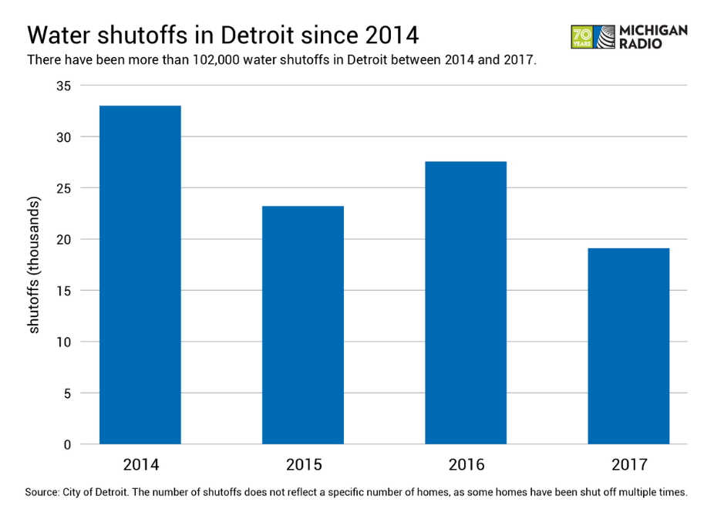
Both can also result in sewer backups into basements. CSOs are found in over 770 communities across the country. In 2004, EPA estimated the cost of controlling CSOs and SSOs at $138 billion. Cities with CSOs also tend to have higher than average low-income populations and a diminishing rate base. For example, Baltimore, which is under consent decree for SSOs, had increases in water and sewer rates of close to 84% between 2010 and 2017 while 13% of the population and 27% of families have annual incomes below $10,000. Water shutoffs are not systematically reported and are therefore difficult to track but according to various sources, 8000 shutoffs were reported for Baltimore in 2015, and 1400 in 2016. In Detroit, 102,000 shutoffs were reported between 2014 and 2017 (see Figure 1), and in Philadelphia, one in five accounts had water turned off at least once between 2012 and 2017.
Figure 1: Water shutoffs in Detroit since 2014
Traditional approaches to stormwater management typically involve “gray infrastructure,” such as curbs, gutters, and piping, all designed to move water away from structures as fast as possible. In contrast, “green infrastructure” utilizes design techniques intended to allow stormwater to infiltrate close to its source to mimic the way water moved through the landscape before it was developed, thereby reducing the flow into CSOs and MS4s. Green infrastructure-based designs comprise a set of site design approaches and small-scale stormwater management practices – rain gardens, roof gardens, retention ponds, etc. – that use natural drainage features or engineered swales and vegetated contours to infiltrate, convey, and treat stormwater runoff. Such technologies also include porous pavement and cisterns. Environmental Protection Agency (EPA) favors these practices as effective means of removing total suspended solids (TSS), nutrients, pathogens, and metals from stormwater, and reducing the volume and intensity of stormwater flows. EPA’s emphasis on green infrastructure continues a trend toward requiring wider use of methods that allow stormwater to percolate into the ground rather than run through a pipe into streams, rivers, and larger water bodies.

Drinking Water Infrastructure and Treatment
Additional costs are associated with drinking water infrastructure and treatment. These may include costs to treat unregulated discharges from agricultural non-point sources. Under the SDWA, EPA sets standards for drinking water quality and with its partners implements various technical and financial programs to ensure drinking water safety. There are many more standards for drinking water then there are for discharges under the CWA, which can lead to some confusion. For example, EPA has adopted the drinking water standard of 10 mg/L for nitrate-nitrogen but few states have a nitrate standard for CWA discharges and there are no standards for agricultural non-point sources. As a result, blue baby syndrome has been eliminated but not algae filled surface water that must be treated at drinking water filtration plants.
Surface waters and aquifers can be contaminated by chemicals, microbes, and radionuclides as well as fertilizers and wastes from animal feedlots. Water can also become contaminated after it enters the distribution system, from a breach in the piping system or from corrosion of plumbing materials made from lead or copper. Disinfection of drinking water has dramatically reduced the prevalence of waterborne diseases; but, there are now concerns about the health impact of unregulated emerging containments such as PFAS and from disinfection contaminants. Other processes may also be used to treat drinking water depending on the characteristics of and contaminants in the source water.

Source Water
Surface water (streams, rivers, and lakes) or ground water can serve as sources of drinking water, referred to as source water. Source water provides water for public drinking water supplies and private water wells. Public utilities treat most water used for public drinking water supplies. Preventing source water contamination to begin with can reduce treatment costs and is the first in a multiple barrier approach to drinking water protection. Protecting source water also reduces risks to public health from exposures to contaminated water. As a general rule, “the less forest in a source water drainage area, the higher the water treatment costs”. EPA provides information and encourages partnerships for source water protection planning. EPA's SDWA and CWA programs both provide tools to protect source water. Additional protection tools can be found in other EPA programs and in various agricultural programs.

Funding
The water affordability issue was front and center in the 1972 debate over passage of the CWA. The costs were recognized, and Congress provided significant resources in the form of grants for Wastewater Treatment Plants (WWTPs) to help municipalities achieve CWA goals. However, federal funding has decreased by over half since the mid-1980s when the initial grant program began to be phased out and was replaced with grants to capitalize State Revolving Loan Funds (SRF). At the same time, spending by states and municipalities have continued to rise. (see figure 2).

Federal, State, Local Government
Given differences in state laws, between public and private utilities, and in the divisions of responsibilities for water management, strategies for addressing the challenge of affordability will also vary across jurisdictions. For example, at the federal level, EPA considers affordability in the enforcement context, when negotiating consent decrees, based on whether the average water bill exceeds a certain percentage of the median household income in the entire community. However, the only remedy is to extend the compliance schedule, which delays the achievement of clean water goals. Lower cost loans and longer payment terms can help. At the local level, state laws determine whether utilities can use revenue from water rates to fund customer assistance programs, and whether local governments can charge fees for stormwater management. Stormwater fees are more equitable for managing stormwater because they can have a relationship to the property size and amount of impervious surface and derive revenue from entities that may not pay a water bill, such as parking lots.
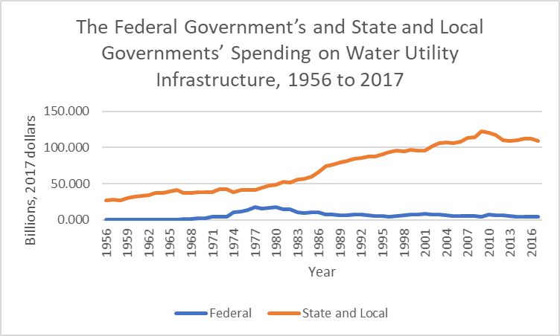
Figure 2: Water Utility Infrastructure Spending, 1956 to 2017 (Source: CBO 2018 https://www.cbo.gov/publication/54539)

Acronyms:

CSO: Combined Sewer Overflow
CSS: Combined Sewer System
CWA: Clean Water Act
MS4: Municipal Separate Storm Sewer System
NPDES: National Pollutant Discharge Elimination System
SDWA: Safe Drinking Water Act
SRF: State Revolving Fund
SSO: Sanitary Sewer Overflow
TSS: Total Suspended Solids
WWTP: Waste Water Treatment Plan

Water Affordability Campaign

Most people in this country have safe, reliable, affordable, water and wastewater services. There are millions of people who do not. Some areas have never had adequate water and wastewater infrastructure, and others struggle with aging systems, unaffordable rates, and poor water quality.
Having an equitable water future means providing all people with access to clean, safe water at a price they can afford. To achieve this, collaboration, and investment by all levels of government, water providers, the private sector, community-based organizations, and others is critical. Sierra Club can be one of the community leaders to ensure an equitable future

Management
- How is water managed in your community?
- More specifically: who has the authority to manage drinking water wastewater and storm water? Are they single or separate entities?
- What is the driving cost of water in your community?
- How do managers of facilities use the State Revolving Loan Fund?
- Does your state issue bonds that can provide a funding source for a consumer assistance program?

Rate Payers
- Are there unfair burdens on water rate payers?
- What is the median household income in your utility service area and what is the income range?
- How does this compare with the typical water bill?
- Do affordability concerns limit compliance activities?
- Who has the authority to address affordability challenges and in what ways?

Stormwater
- Do you pay additional charges for storm water management or other forms of water quality protection?
- What approaches are used to manage storm water?
- If green infrastructure is being used, what are the specific cost-benefits in your community?
- What are barriers to implementing green infrastructure project

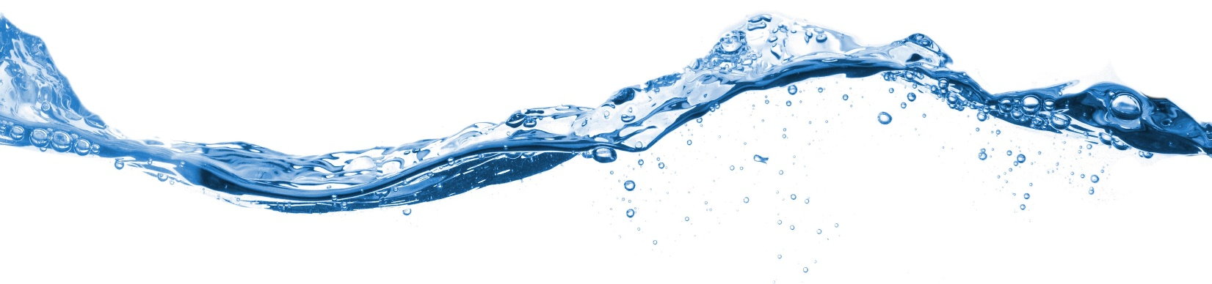Water Shutoffs
What Needs To Be Done and What You Can Do

Millions of people nationwide are at immediate risk of shutoff or already shutoff. State and local water shutoff moratoriums expiring and possible future increases in water shutoffs due to the economic downturn only increase the chances of more water shutoffs.

The Sierra Club is advocating for utilities to:
- Suspend shutoffs for nonpayment
- Order reinstitution of services without being assessed a reconnection fee
- Waive late fees, effective immediately, until further notice
- Suspend the collection and credit reporting for nonpayment

What should be in a customer assistance program (CAP)
- Include a bill insert in the next billing cycle noting all financial assistance or flexible payment programs available, and how the customer can access more information about such programs.
- Description of the specific eligibility requirements and timeframe for programs specific to coronavirus relief.
- Utilities should make this information accessible to all customers.
- Submit a CAP to their regulating authority that describes the steps each utility will take to address the economic hardship of residential customers.
- The plan should consider reforms to the utility’s working definition of “low-income”

Reach out to the utility itself
Sometimes it is not clear what type of utility yours is or who regulates it. Go to your utility website for that information and see if they are doing disconnections. If it’s not on their website then give them a call asking.

- Call them as a customer to ask them to stop disconnecting because of nonpayment
- Send them an email outlining the best course of action for utilities during this time
- Use social media to reach out to them

Collaborate with frontline groups
There is an opportunity to partner with the folks on the ground who are already doing water shut off advocacy. Most of these groups have been doing this work well before the public health pandemic. Reaching out to them to help lift up their work and provide support should be the first step. Be sure to connect with other Sierra Club staff or volunteers who may already have a working relationship.

In the circumstance where there is not an existing Sierra Club relationship with a frontline group focused on water shutoffs, then you could build a relationship and find ways to be an ally on the issue of water shut-offs. Foster an atmosphere where everyone can ask for and give feedback without judgment. Once the new relationship is established around shut off you may find ways to collaborate on other issues.

Water is a Human Right
Lack of access to water has a devastating effect and has consequences for the realization of other human rights.

If you choose to build a relationship, there is some guidance from the Organizing Department for you to review to help guide your outreach. In addition, there is a power point that the Organizing Department has that you might find helpful. The principles and processes provide important guidance in determining who to reach out to and how to build even a couple relationships with groups working in the area of interest. Refer to Sierra Club’s and Justice Principles Equity Language about best practices around using respectful, thoughtful language in your communications.

Campaign tactics and principles
- AddUp is Sierra Club’s online engagement hub, where you can easily build a single AddUp campaign that will host a variety of online actions your supporters can take
- Reach out to your networks and social media, emphasizing what volunteers gain by giving their time
- Send email invitations to ask for volunteers or hold a webinar or conference call as a first step. Target specific groups, like area residents, activists, or environment-related professionals, neighborhood associations, political parties, local alumni associations, social justice organizations, faith-based organizations, or local student groups.
- Determine effective methods of communication based on what people feel comfortable using.
- Respect people’s time keep folks involved with clear expectations and accountability, delegate responsibilities according to people’s expertise or opportunity to grow. and show their impact.

Regardless of whether your campaign is successful show appreciation and express the impact and hard word by volunteers with a thank you or gathering to celebrate.

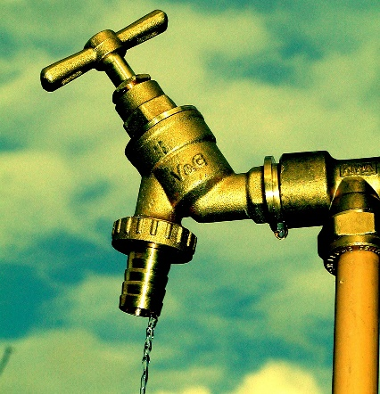
Water Utilities
The Business of Providing Water
Because of COVID- 19 utilities are hard hit, they project their losses in revenue between 10% - 40 %. Drinking water losses are projected to be fourteen billion and wastewater losses could be seventeen billion. One third of utilities are going to be in financial trouble by the end of 2020.

Funding Customer Assistance Programs
A Customer Assistance Programs (CAP) is a way affordability is addressed by utilities.
- The University of North Carolina Environmental Finance Center has an affordability assessment tool that uses census data to show, for example, that in Cincinnati, one making less than $10,000/year would pay over 11% of income in water and sewer bills.
- If it is determined that a CAP is needed, the next step is determining who is eligible and how it can be funded. Some states do not allow use of rate revenue to fund CAPs while in others, the authority is less clear.
- Some have found ways to work-around existing laws. For example, Atlanta changed city codes to enable CAP funding from water rate revenue. A review of state laws and case studies can be found in a report titled Navigating Legal Pathways To Rate-Funded Customer Assistance Programs: A Guide For Water And Wastewater Utilities that was financed by several water utility associations.
- Other considerations are the equitable allocation of costs and understandability by customers.

The basic choice for funding a CAP are financed by the rate structure, government transfers or public assistance funds.
- Building the programs into the rate structure should be justified without excessive cross-subsidies.
- Government subsidies should be used when they bolster revenues of utilities seeking to meet their increased funding needs.
- Public assistance funds with an emphasis on partnerships to address multiple needs of low-income residents, including those not billed directly by utilities, should be sought.

State Revolving Funds (SRF)
The Clean Water State Revolving Fund (CWSRF) program is a federal-state partnership that provides communities low-cost financing for a wide range of water quality infrastructure projects. This is Environmental Protection Agency’s (EPA) website, https://www.epa.gov/cwsrf/clean-water-state-revolving-fund-cwsrf-resources#lawsreg. The Drinking Water State Revolving Fund (DWSRF) is also a federal program. The EPA allocates these funds to states through annual capitalization grants that are based on a needs assessment. To receive this federal funding, states must provide matches totaling 20 percent of their annual capitalization grant from the EPA. Collectively, these SRF grants are the largest source of federal water infrastructure funding.

Federal law places a cap on subsidized assistance that may inhibit states from leveraging their SRFs’ financial capital. The cap on subsidized assistance, which is set in statute at 30 percent of EPA’s annual capitalization grant, was originally put in place to ensure that states did not give away too much funding in the programs’ early years. Currently, states that want to provide more subsidized assistance than Congress allows must create separate and somewhat duplicative state-financed water infrastructure programs. A handful of these state programs exceed the amount of assistance provided through those states’ CWSRF or DWSRF.

One way to increase funding is for states to make use of their ability to issue SRF-backed loan guarantees to communities. This would enable communities to raise funds more easily and cheaply from private financial markets. States should leverage additional funding for their SRF programs through the issuance of bonds, which is a low-cost way to increase their SRFs’ financial capacity. Finally, Congress should grant states the flexibility to use newly generated funding for SRF grants or subsidized assistance.

Millions of people nationwide are at immediate risk of shutoff or already shutoff. State and local water shutoff moratoriums expiring and possible future increases in water shutoffs due to the economic downturn only increase the chances of more water shutoffs. We can help communities put in place programs to make sure everyone has water

Underinvestment at the federal level and underutilization at the state level have left much of the SRFs’ capacity untapped. As a result, states are failing to provide all the funding that is possible to ensure safe, reliable, and resilient water infrastructure.

From a utility perspective, full cost recovery and revenue stability have higher priority than encouraging conservation and maintaining affordability, which they often do not see as part of their job.

Climate Change
The impact of climate change is increasingly important to the design of infrastructure investment programs. Water resources will change in both quantity and quality. Storm water and wastewater facilities’ infrastructure will face greater risk of damage caused by storms, floods and droughts. The effect of the climate change will manifest from difficulties in operations to disrupted services and increased cost of the water and wastewater services. The water utilities adaptation option should be screened for a financial viability using the utility’s established evaluation processes for investment planning. ‘No-regret’ investments are worth doing anyway, no matter what the eventual climate change stress may be on a system.

Reducing Costs
Given that rates only go so far, it is also important to find ways to reduce costs. Integrating water management across sectors and seeking improvements in efficiency through management tools or infrastructure improvements can yield co-benefits. For example, leakage reduction brings a cascade of wider benefits, including reduced greenhouse gas emissions which may be eligible for specialist climate change mitigation finance

Utilities can reduce their costs through good operation and maintenance of facilities. Among the ways to reduce costs to customers is to give landlords an incentive to fix leaks rather than pass the costs along to their tenants. Tenants typically don’t see the actual water bill, which is the way leaks are usually detected.

Green Infrastructure
One point of leverage is the requirement to allocate 10% of State Revolving Funds to Green Infrastructure (GI). It is important to show up at hearings and to make sure these funds are effectively used for actual GI and not for lining streets in concrete. Utilities tend to think they can get more bang for the buck with gray infrastructure, but a case can be made that green infrastructure can reduce costs as a complement to gray.

American Rivers 2013 Drinking Water Infrastructure: Who pays and how (and for what?)
Clean Water for All Coalition 2018 Water, Health and Equity: The Infrastructure Crisis Facing Low-Income Communities & Communities of Color – and How to Solve It
NRDC May 2018 https:s//www.nrdc.org/sites/default/files/state-revolving-fund-water-infrastructure-ip.pdf

Contact:  Debbie Neustadt  debbieneustadt@gmail.com | Sierra Club  National Water Sentinels  Facebook page https://www.facebook.com/groups/103816443590/

Mumm, Jason and Julius Ciaccia, Improving the Narrative on Affordability and the Measurements We Need to Take Us There, Journal-American Water Works Association 109(5), 2017,: 42–48.
Congressional Budget Office 2018 Public Spending on Transportation and Water Infrastructure, 1956 to 2017. https://www.cbo.gov/publication/54539
American Water Works Association, Buried No Longer: Confronting America’s Water Infrastructure Challenge, 2012.
33 U.S.C. §1251 et seq. (1972)
A consent decree is an agreement or settlement that resolves a dispute between two parties without admission of guilt (in a criminal case) or liability (in a civil case).
GAO 2016 Water Infrastructure: Information on Selected Midsize and Large Cities with Declining Populations GAO-16-785 https://www.gao.gov/products/GAO-16-785
National Academy of Public Administration 2017 Developing a New Framework for Community Affordability of Clean Water Services. Washington DC https://www.napawash.org/studies/academy-studies/developing-a-new-framework-for-community-affordability-of-clean-water-servi
Weiner, Deborah, Insurmountable bills lead to water shutoffs in Baltimore, Baltimore Sun, February 13, 2017. http://www.wbaltv.com/article/insurmountable-bills-lead-to-water-shutoffs-in-baltimore/8775838
Walton, Brett, Philadelphia Water Rate Links Payments to Household Income, Circle of Blue, May 16, 2017. http://www.circleofblue.org/2017/water-management/pricing/philadelphia-water-rate-links-payments-household-income/
Reese, A.J., 2001 Stormwater Paradigms. https://www.foresternetwork.com/stormwater/stormwater-management/article/13001153/stormwater-paradigms
EPA Performance of Green Infrastructure. https://www.epa.gov/green-infrastructure/performance-green-infrastructure (accessed 8-6-2019
Although agricultural non-point sources are not regulated, some pollution reduction is achieved through voluntary incentive programs for implementing Best Management Practices.
Freeman, J., Madsen, R., & Hart, K. (2008). Statistical Analysis of Drinking Water Treatment Costs, Source Water Quality, and Land Cover Characteristics. Trust for Public Land. Retrieved from http://www.tpl.org/land-use-and-drinking-water-treatment-costs-0
Adler, R. W., Landman, J. C., & Cameron, D. M. (1993). The Clean Water Act 20 years later. Washington, D.C: Island Press.

