

**Sewage Wastewater Residuals Fact Sheet**

**OUR URBAN AND INDUSTRIAL WASTE STREAM**

**THREATENS US AND THE ENVIRONMENT**

In 1969, flammable oil products, sewage and toxic debris in the Cuyahoga River caught fire as it wound its way through Cleveland, Ohio. The event caught national attention and focused the nation on the health and environmental threats from pollution produced from urban and industrial waste. Public alarm led to the passage of the Clean Water Act in 1972 and the construction of wastewater sewage processing plants, the principal means of disposing of urban and industrial sewage and liquid wastes.

**SEWAGE TREATMENT DOES NOT MEAN CLEAN OR SAFE WASTE**

Sewage processing plants, which can receive any of over 90,000 contaminants a day,

separate sewage solids from the liquid waste stream. These pollutants, in the form of highly concentrated solids and diluted effluent, consist of mixtures of lead, mercury, arsenic, thallium, PCBs, PFAs, highly complex, biologically active toxins, pathogens, superbugs, mutagens, pesticides, microplastics, radioactive wastes, pharmaceuticals, steroids, flame retardants, dioxins, and/or their combinations. The separated liquid is treated and directed back into open waters.

**DISPOSAL DOES NOT MEAN DISAPPEAR - WHAT GOES AROUND COMES AROUND**

Since 1993, millions of tons of hazardous sewage sludge have been spread on agricultural and forest lands, offered to unsuspecting farmers, landscapers and homeowners as a soil amendment or compost, without the US EPA admitting what harmful contaminants and pathogens the products contain. The toxic effluent is spread on farmland and recreational sites, where it flows and seeps into surface and ground water. This has led to the contamination of land and water across the country and produce we grow.

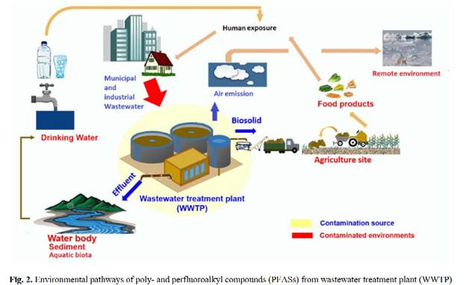

Source: Hamid, H., & Li, L. (2016). Role of wastewater treatment plant in environmental cycling of poly- and perfluoroalkyl substances. Ecocycles, 2(2), 43-53

**THE IMPACT OF THESE PRACTICES IS DOCUMENTED**

The study “[Survey of organic wastewater contaminants in biosolids [“biosolids” is an EPA designation for “treated sewage sludge”] destined for land application](http://dx.doi.org/10.1021/es0603406)” examined nine different biosolid products, produced by municipal wastewater processing plants in seven different states, finding 87 different chemicals, with fifty-five chemicals found in one product alone.

In 2009, EPA published the *Targeted National Sewage Sludge Survey*. The survey focused on 74 processing plants in 35 states that treated more one million gallons per day. It concluded that all sewage sludge contains toxic and hazardous materials. <https://www.epa.gov/sites/production/files/2018-11/documents/tnsss-sampling-anaylsis-tech-report.pdf>

In 2018, EPA’s Office of Inspector General (OIG) published its audit of the agency’s “Biosolids” Program and found that ***the EPA was unable to assess the impact of hundreds of unregulated pollutants in land-applied “biosolids” on human health and the environment.*** To date, the EPA has identified 352 pollutants in biosolids, out of an unknown and incalculable total that frustrates any meaningful risk assessments; 61 of these pollutants have been categorized as hazardous by other federal program. These pollutants currently are not considered for further regulation because the agency lacks the data and tools necessary to assess the health and environmental risks.

<https://www.epa.gov/sites/production/files/2018-11/documents/_epaoig_20181115-19-p-0002.pdf>

On April 8, 2019, the OIG issued a management alert informing the US EPA that its Toxic Release Inventory data pertaining to releases of hazardous substances from publicly owned wastewater processing plants are inaccurate. As a result, the public and researchers are not receiving complete and timely information about environmental conditions affecting human health.

<https://www.epa.gov/office-inspector-general/report-management-alert-certain-toxic-release-inventory-data-disclosed>

Studies report the uptake of sewage contaminants in edible plants. Microplastics accumulate on pores in seed capsule and delay germination and root growth. <https://www.sciencedirect.com/science/article/pii/S0045653519306095?fbclid=IwAR3grg_8Xv2OL4KbSKgQYvBPW28wz54Mmw940ldlyYSKWpTXy_8OV2eopcM>

The ubiquity of anthropogenic toxic marine pollution raises concerns about how the ingestion of anthropogenic debris by marine animals may impact human health. <https://www.nature.com/articles/srep14340#ref38>

**JOIN OUR TEAM! FIGHT TO PROTECT OUR SOIL AND WATER**

The Sierra Club opposes the use of contaminated toxics and/or pathogen containing waste as a compost ingredient and the application of municipal sewage sludge as a fertilizer.

([Compost Policy](https://www.sierraclub.org/sites/www.sierraclub.org/files/uploads-wysiwig/compost.pdf),[Sewage Sludge Policy](https://www.sierraclub.org/sites/www.sierraclub.org/files/uploads-wysiwig/LandApplicationSewageSludge.pdf) and  [Agriculture and Food](https://www.sierraclub.org/policy/agriculture/food).)

Visit the documents posted on our Grassroots Network Wastewater Residuals Team. <https://content.sierraclub.org/grassrootsnetwork/teams/wastewater-residuals>