Inflation Reduction Act
Resources
Tax Law Changes
This major legislation will affect individuals, businesses, tax exempt and government entities.

- Clean Vehicle Credits
  - Credits for New Clean Vehicles Purchased in 2023 and After
  - Credits for New Electric Vehicles Purchased in 2022 and Before
  - Credits for Used Clean Vehicles
  - Commercial Clean Vehicle Credit
  - Incentives for Biodiesel, Renewable Diesel and Alternative Fuels
- Credits for Individuals
  - Home Energy Tax Credits
  - Energy Efficient Home Improvement Credit
  - Residential Clean Energy Credit
- Credits and Deductions for Businesses
  - Advanced Energy Project CreditPDF
  - Credit for Carbon Oxide Sequestration
  - Energy Credit for Solar and Wind FacilitiesPDF
  - Energy Efficient Home Credit
  - Incentives for Biodiesel, Renewable Diesel and Alternative Fuels
  - Second Generation Biofuel Incentives
  - Sustainable Aviation Fuel Credit

IRS WEBSITE
Credits and Deductions Under the Inflation Reduction Act of 2022
- The law includes a wide range of tax law changes that IRS will have to implement.
- Since the Inflation Reduction Act is a 10-year plan, the changes won't happen immediately. The IRS is working to implement the law as quickly as we can.

IRS FREQUENTLY ASKED QUESTIONS
- New, Previously Owned and Qualified Commercial Clean Vehicles Credit
  - Topic A — Eligibility Rules for the New Clean Vehicle Credit
  - Topic B — Income and Price Limitations for the New Clean Vehicle Credit
  - Topic C — When The New Requirements Apply To The New Clean Vehicle Credit
  - Topic D — Eligibility Rules for the Previously-Owned Clean Vehicles Credit
  - Topic E — The Income and Price Limitations Previously-Owned Clean Vehicles
  - Topic F — Claiming The Previously-Owned Clean Vehicles Credit
  - Topic G — Qualified Commercial Clean Vehicles Credit

- Energy efficient home improvements and residential clean energy property credits
  - Energy Efficient Home Improvement: Qualifying Expenditures and Credit Amount
  - Residential Clean Energy Property: Qualifying Expenditures and Credit Amount
  - Energy Efficiency Requirements
  - Qualifying Residence
  - Labor Costs
  - Timing of Credits
  - General Questions
  - Examples

PUBLICATIONS
- Publication 5724, Credit for Previously Owned Clean Vehicles
Publication 5724, Credit for Previously Owned Clean Vehicles - If you are interested in claiming the commercial clean vehicle credit for purchasing a commercial clean vehicle or vehicles, a tax credit is available for each qualifying commercial clean vehicle purchased each year.

- Publication 5724 (sp), Credit for Previously Owned Clean Vehicles (Spanish Version)
Publication 5724 (sp), Credit for Previously Owned Clean Vehicles (Spanish Version) - If you are interested in claiming the commercial clean vehicle credit for purchasing a commercial clean vehicle or vehicles, a tax credit is available for each qualifying commercial clean vehicle purchased each year.

- Publication 5724-A, Credit for Clean Vehicles
Publication 5724-A, Credit for Clean Vehicles - If you are interested in claiming the clean vehicle credit for purchasing a new clean vehicle after Aug. 16, 2022, a tax credit is available only for qualifying clean vehicles.

- Publication 5724-A (sp), Credit for Clean Vehicles (Spanish Version)
Publication 5724-A (sp), Credit for Clean Vehicles (Spanish Version) - If you are interested in claiming the clean vehicle credit for purchasing a new clean vehicle after Aug. 16, 2022, a tax credit is available only for qualifying clean vehicles.

- Publication 5724-B, Credit for Commercial Clean Vehicles
Publication 5724-B, Credit for Commercial Clean Vehicles - If you are interested in claiming the commercial clean vehicle credit for purchasing a commercial clean vehicle or vehicles, beginning in 2023, a tax credit is available for each qualifying commercial clean vehicle purchased each year through Dec. 31, 2032.

- Publication 5724-B (sp), Credit for Commercial Clean Vehicles (Spanish Version)
Publication 5724-B (sp), Credit for Commercial Clean Vehicles (Spanish Version) - If you are interested in claiming the commercial clean vehicle credit for purchasing a commercial clean vehicle or vehicles, beginning in 2023, a tax credit is available for each qualifying commercial clean vehicle purchased each year through Dec. 31, 2032.

IRS SOCIAL MEDIA
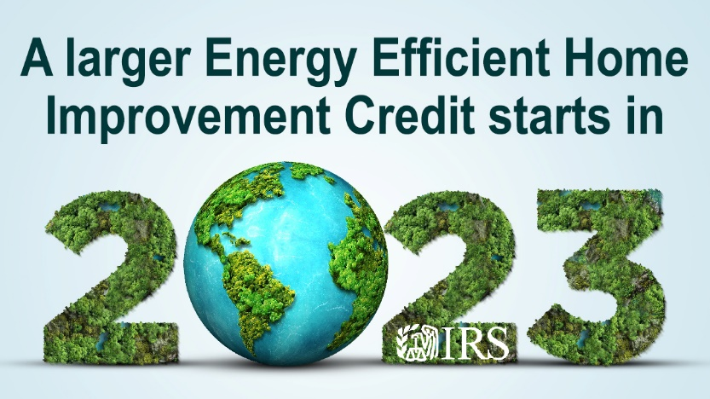
- Ready for clean energy? See the #IRS frequently asked questions about energy efficient home improvements and residential clean energy property credits. http://ow.ly/Ic3g50MaPxs

- Take a look at the #IRS updates to learn how you may benefit from recent changes to the credits for energy efficient home improvements and residential clean energy property. http://ow.ly/Ic3g50MaPxs

- Wondering how you may claim an #IRS tax credit for making your home more energy-efficient? Check out our frequently asked questions: http://ow.ly/Ic3g50MaPxs

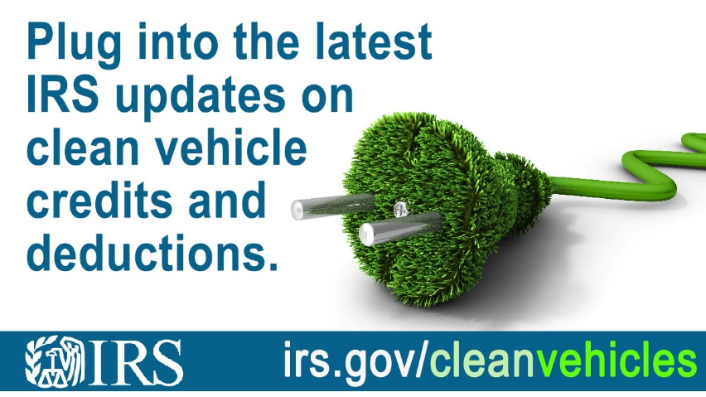
- Check out the most recent updates to the vehicle classification standard for clean vehicle tax credits under Inflation Reduction Act: http://ow.ly/jOUg50MJ8iR

- New guidance changes the classification standard by which vans, sport utility vehicles, pickup trucks and other vehicles are defined for the clean vehicle credits. Details from #IRS at: http://ow.ly/jOUg50MJ8iR

- #IRS has updated information related to new, previously owned and qualified commercial clean vehicle credits. Take a moment now and see how this may benefit you: http://ow.ly/jOUg50MJ8iR

- Recent changes may benefit you → Check out the #IRS frequently asked questions on the new clean vehicle credit, previously owned vehicle credit and qualified commercial clean vehicles credit: http://ow.ly/jOUg50MJ8iR

