Statement of Application Purpose

The Sierra Club's San Francisco Bay Area ICO Rafting Program introduces urban youths and adults, who may not otherwise have the access or opportunity, to the beauty and challenges of our wild rivers and lands. In so doing, ICO strives to inspire their target population through education, active engagement, and river guide training to enjoy and treasure our natural environment.

As a volunteer organization, ICO is not a commercial outfitter. Participant trips are for the benefit of the Agency Groups served by ICO. Volunteer Guides and Apprentice Guides teach and assist the group with tasks throughout the trip. The ICO volunteers guide the boats down the river while working with their participant crews to ensure a safe river experience. On all participant trips ICO Rafting encourages teambuilding and education (both historical and environmental) with the participant group. During off river activities teamwork is additionally encouraged through the activities required to set up camp, cook dinner, clean dishes and play games.

ICO rafting is an all-volunteer organization and river trips are provided by ICO to Agency Groups at low cost. However, it must be acknowledged that there are inherent costs associated with an outdoor river experience such as travel to and from the river, food, river put-in fees, parking fees, camping fees, and food costs. As a non-profit volunteer agency none of these costs are charged by ICO to the Agency Group. If your group is selected to participate in an ICO River Trip an ICO trip leader will be assigned to your group who will work with your group leader to coordinate planning your trip, including the necessary financial planning to facilitate the trip. ICO Rafting does budget financial assistance to support groups with identified financial needs.

The following application is intended to provide ICO Rafting with the necessary information to determine your Agency Group’s applicability to the ICO mission. When completing your application as a new Agency Group, please take note of the above-mentioned information. ICO Rafting does not share your group information with any other agency and all information required in this application is for the express purpose of assisting ICO in determining your group’s suitability for the ICO mission. Only the Outreach Coordinator and the Group Selection Committee will review the information provided in this application.

The application due date is April 1, 2023. Following the submission of your application the Group Selection Committee will review all applications submitted and schedule the 2023 calendar. The Outreach Coordinator will contact your group on or before April 28, 2023 to notify you of the status your acceptance and, if selected, the date that your group has been calendared with ICO.

Submit your completed application to the Outreach Coordinator via email to:
outreach@icorafting.org

For ease of reference, when saving this application please update the completed application file name to include your group name and the year 2022.

Agency Group Contact Information

Group Name:
Group Contact / Leader:
Group Address:
Phone Number:
Email:
Preferred form of contact:

Agency Group Background

Please describe your group in the data space below. What is your group’s purpose/mission?

Background Group Mission:

Why does your Agency Group wish to partner with ICO? What are your goals for conducting an ICO River Outing?

ICO Partnership Goals:

Has your group participated with any other ICO chapter other than the San Francisco Rafting Chapter? If so, please note the dates the trips were conducted and describe the outing experience.

Prior ICO Outings:

How did you come to know of ICO Rafting? Are you partnered with a particular ICO Volunteer? If so, please note the volunteer’s name.

ICO Contact:

Agency Group Background

Describe your group’s background such as group cohesiveness and organizational structure. For instance, what activities does your agency conduct to benefit your service population? Does your group encourage/teach group cooperative behavior?

Agency Background Activities:

ICO aims to serve populations that would not otherwise have the opportunity to enjoy the outdoor experience. In the data space below summarize the demographic population of your agency group. Please include objective data to categorize the ethnic and social background of your agency group’s service population: for instance, if your group is associated with a school include the percentage of youth that receive free lunch programs. References to cities, neighborhoods, and other social demographic information are helpful.

Demographic
Information:

What is the age range of your agency group’s service population?

Participant Age Range:

What is the source of funding for your Agency?

Agency Funding:

Agency Group Background

Are you currently working with any other whitewater rafting agency or organization to schedule a whitewater outing in 2022?

Whitewater trips scheduled:

Has your group ever participated in a whitewater rafting outing? If so, please list the river, the agency you partnered with, and note the date the trip(s) had occurred.

Whitewater Experience:

ICO conducts most trips on the South Fork of the American River, a class III river located within 2 hours from the Bay Area. Indicate if your group is interested in rafting on more advanced rivers. Do you foresee problems associated with traveling longer distances for advanced rivers? Describe why you feel your group would be qualified to raft advanced rivers.

Additional River Justification:

Participant Information

The maximum group size that ICO can accommodate is 25, total. An additional requirement is that participants should be at least 13 years old and weigh less than 240 pounds to ensure the safety of the participant.

Number of participants:
Number of group leaders/staff/adults:
Group Total:

Participant Information

ICO estimates the cost for hosting a whitewater outing is approximately $60 to $80 per person for a weekend trip. These estimates are only for expenses incurred for the trip, such as food, camping, transportation, land use permits and other miscellaneous fees. Please note that ICO does not collect any money, these costs are inherent towards
hosting an outdoor experience. ICO does provide limited financial assistance to those groups that demonstrate need.

Can the participants cover their own costs?
If not, can your group help cover the costs of the trip?

If your participants are not able to cover their costs and your agency is unable to assist in covering the costs associated with the trip, please document rational and proposed fundraising ideas/goals.

Fundraising
Rationale:

ICO provides all whitewater rafting gear, including wetsuits, and PFDs (personal flotation devices commonly known as “life-vests”) as well as camp-kitchen cookware. Will your group require any additional outdoor equipment such as sleeping bags, tents, or other supplies? Please document the quantity.

Outdoor Gear Required:

ICO volunteers are unable to drive or carpool with Agency participants and therefore the transportation to and from the river is entirely the responsibility of the Agency Group. Please consider your transportation plans and document the types of vehicles you will use to transport to and from the river. Take note that trucks are especially helpful in transporting gear during the outing.

Vehicles:

Trip Dates

The ICO rafting season runs from June through September. Most groups who apply are accommodated, however trips in June are typically the most desired. Therefore, flexibility in dates is important. Make sure you specify whether you are applying for a one-day trip or two-day (weekend) trip.

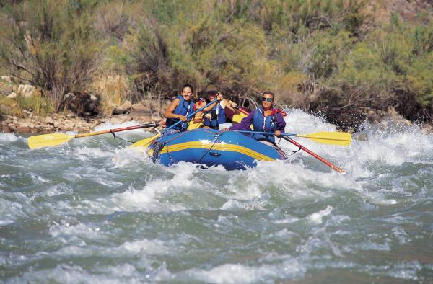 | Consider the following holidays when planning your trip. These weekends are difficult to staff.  May 29th, Memorial Day  June 18th, Father’s Day  July 4th, Independence Day  September 4th, Labor Day
It is highly encouraged that you select a two-day trip to best experience the outdoors through camping and to maximize the cost of driving up to the river for your participants and our ICO guides!

List your Primary preferred dates:
First Preference:
Second Preference:
Third Preference:
Fourth Preference:

If you have interest in conducting more than one trip with ICO during the 2022 season, please list those preferred dates:
First Preference:
Second Preference:
Third Preference:
Fourth Preference:

