Changing the Narrative - Words of Wisdom
(10 November 2022)

Use the following to clarify your position on an issue in emails, LTEs, position papers, image titles, or discussions. Changing the narrative is the first step toward changing behavior.

Thinking Globally
"Our modern industrial economy takes a mountain covered with trees, lakes, running streams and transforms it into a mountain of junk, garbage, slime pits, and debris." ~Edward Abbey
"The more clearly we can focus our attention on the wonders and realities of the universe about us the less taste we shall have for the destruction of our race. Wonder and humility are wholesome emotions, and they do not exist side by side with a lust for destruction." ~Rachel Carson, Speech accepting the John Burroughs Medal
"I had a feeling it's tiny, it's shiny, it's beautiful, it's home, and it's fragile." ~Michael Collins, Apollo 11 Astronaut on seeing the earth from space.
"Insanity is doing the same thing over and over again and expecting different results." ~Albert Einstein
"We shall require a substantially new manner of thinking if mankind is to survive." ~Albert Einstein
"Our ability to reach unity in diversity will be the beauty and the test of our civilization." ~Mahatma Gandhi
"There is a sufficiency in the world for man's need but not for man's greed." ~Mohandas K. Gandhi
"Never doubt that a small group of thoughtful, committed, citizens can change the world. Indeed, it is the only thing that ever has." ~Margaret Mead
"Preserve and cherish the pale blue dot, it's the only home we've ever known." ~Carl Sagan
"When we try to pick out anything by itself, we find it hitched to everything else in the universe." ~John Muir
"A man is rich in proportion to the number of things which he can afford to let alone.” ~ Henry David Thoreau
"Everything changes. Everything is connected. Pay attention! ~Zen Buddhism teaching

Preserving Nature
"Never, no, never did nature say one thing and wisdom another." ~Edmund Burke
"Man has been endowed with reason, with the power to create, so that he can add to what he's been given. But up to now he hasn't been a creator, only a destroyer. Forests keep disappearing, rivers dry up, wild life's become extinct, the climate's ruined and the land grows poorer and uglier every day." ~Anton Chekhov
"When the soil disappears, the soul disappears." ~Ymber Delecto
"Everything in nature invites us constantly to be what we are." ~Gretel Ehrlich
"When a man says to me, "I have the intensest love of nature," at once I know that he has none." ~Ralph Waldo Emerson
"The environment is where we all meet; where all have a mutual interest; it is the one thing all of us share." ~Lady Bird Johnson
"We abuse land because we regard it as a commodity belonging to us. When we see land as a community to which we belong, we may begin to use it with love and respect." ~Aldo Leopold, A Sand County Almanac
"Harmony with land is like harmony with a friend; you cannot cherish his right hand and chop off his left." ~Aldo Leopold, A Sand County Almanac
"The richness I achieve comes from Nature, the source of my inspiration." ~Claude Monet
"Let us a little permit Nature to take her own way; she better understands her own affairs than we." ~Michel de Montaigne
"Thousands of tired, nerve-shaken over-civilized people are beginning to find out that going to the mountains is going home; that wildness is a necessity." ~John Muir
"In every walk in nature one receives far more than he seeks." ~John Muir
"The loss of biodiversity is a silent killer. It’s different from climate change, where people feel the impact in everyday life. With biodiversity, it is not so clear but by the time you feel what is happening, it may be too late." ~Cristiana Pasca Palmer, Executive Director, UN Convention on Biological Diversity
"There is no Wi-Fi in the Forest, but I promise you will find a better connection." ~Ralph Smart
"Nature is not a place to visit. It is home." ~Gary Snyder
“In Wildness is the preservation of the World.” ~Henry David Thoreau
"Heaven is under our feet as well as over our heads." ~Henry David Thoreau
"Unless we wish to pauperize the natural world drastically and permanently...then we, the current inheritors of this beautiful world, must take more serious action to preserve the rest of life." ~Dr. Edward O. Wilson
"The best time to plant a tree was 20 years ago. The second best time is now." ~Zen Buddhism saying
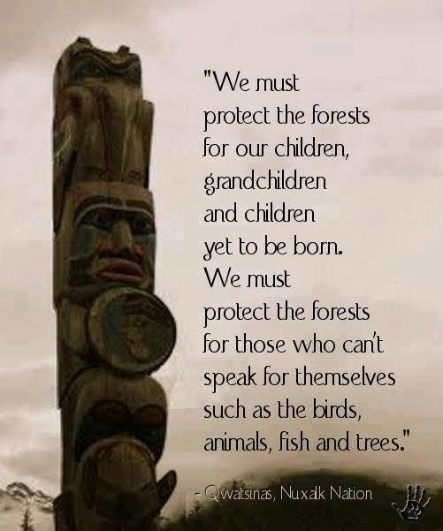

Muir on Conservation
"No blind opposition to progress, but opposition to blind progress." ~John Muir
"The world, we are told, was made especially for man, a presumption not supported by all the facts. A numerous class of men are painfully astonished whenever they find anything, living or dead, in all God's universe, which they cannot eat or render in some way what they call useful to themselves." ~John Muir

Muir on Trees and Forests
"The wrongs done to trees, wrongs of every sort, are done in darkness of ignorance and unbelief, for when the light comes, the heart of the people is always right." ~John Muir
"And into the forest I go, to lose my mind and find my soul." ~John Muir
"Between every two pine trees is a doorway leading to a new way of life." ~John Muir
"Happy the man to whom every tree is a friend." ~John Muir
"The clearest way into the Universe is through a forest wilderness." ~John Muir
"I never saw a discontented tree. They grip the ground as though they liked it." ~John Muir
"Come to the woods, for here is rest." ~John Muir

Native Wisdom of Indigenous Peoples
"It does not require many words to speak the truth." ~Chief Joseph
"The earth is the Mother of all people, and all people should have equal rights upon it." ~Chief Joseph
"Everything an Indian does is in a circle, and that is because the power of the world always works in circles." ~Black Elk
"The old Lakota was wise. He knew that a man's heart away from nature becomes hard." ~Luther Standing Bear
"We do not inherit the earth from our ancestors; we borrow it from our children." ~Chief Seattle
"All things are bound together. All things connect." ~Chief Seattle
"Treat the earth well - it was not given to you by your parents; it was loaned to you by your children. We do not inherit the Earth from our ancestors; we borrow it from our Children." ~Chief Crazy Horse
"Only when the last tree has died and the last river been poisoned and the last fish been caught will we realize we cannot eat money." ~Cree Indian Proverb

~COP 26 breakout session on indigenous peoples' mindset to address climate change

